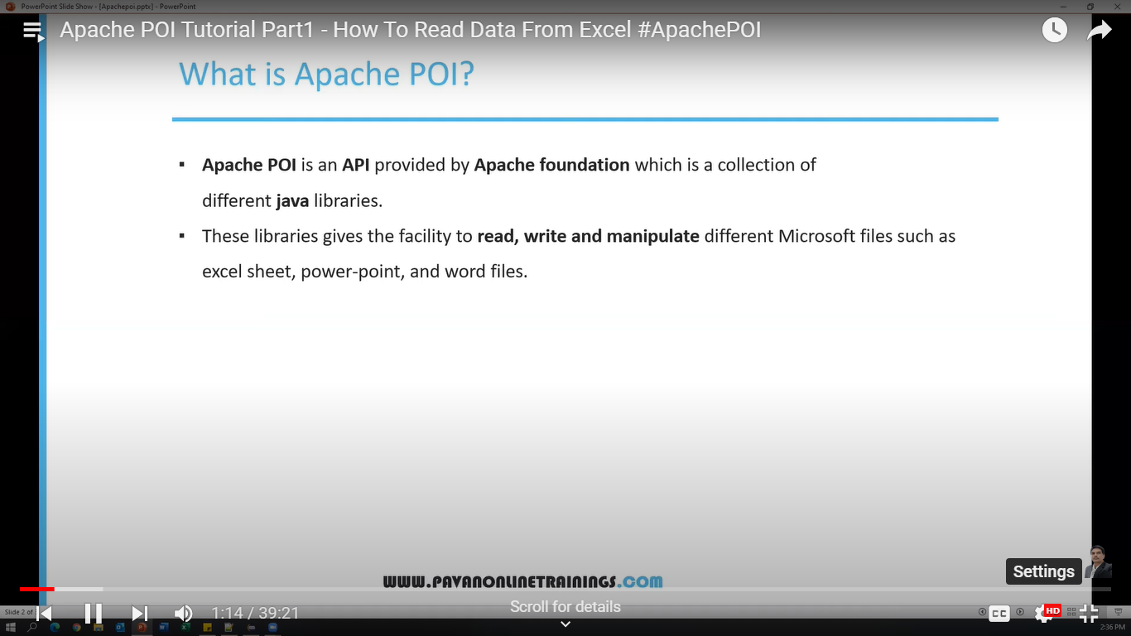

We use in Data driven testing –

If we are using ms excel before 97 version- .xls

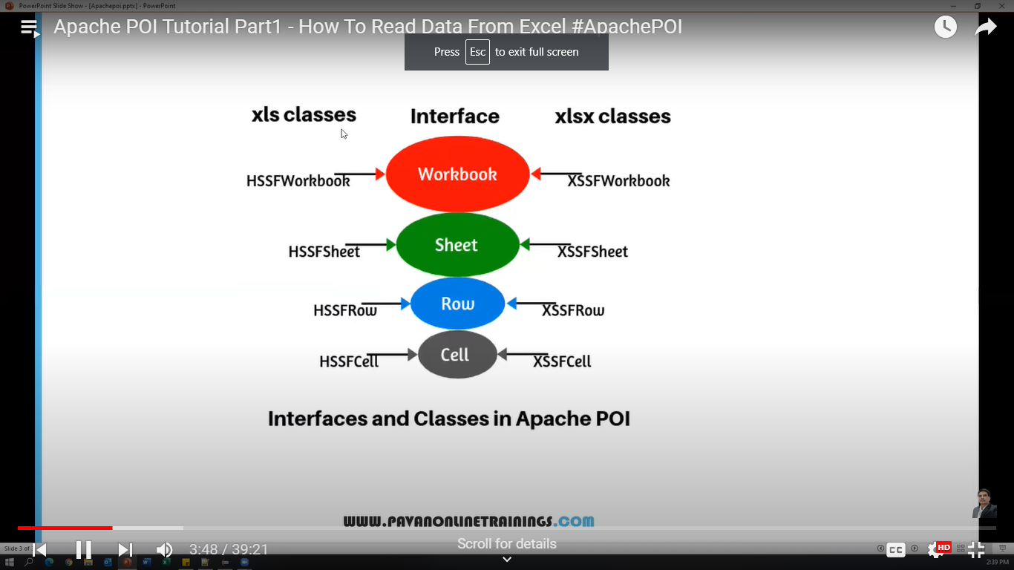

**Workbook:** HSSFWorkbook and XSSFWorkbook classes implement this interface  
**HSSFWorkbook:** It is a class represents XLS file  
**XSSFWorkbook:** It is a class represents XLSX file  
**Sheet:** HSSFWorkbook and XSSFWorkbook classes implement this interface  
**HSSFSheet:** It is a class represents a sheet in a XLS file  
**XSSFSheet:** It is a class represents a sheet in a XLSX file  
**Row:** HSSFWorkbook and XSSFWorkbook classes implement this interface  
**HSSFRow:** It is a class represents a row in a sheet of XLS file  
**XSSFRow:** It is a class represents a row in a sheet of XLSX file  
**Cell:** HSSFWorkbook and XSSFWorkbook classes implement this interface  
**HSSFCell:** It is a class represents a cell in a row of XLS file  
**XSSFCell:** It is a class represents a cell in a row of XLSX file

Using for loop-

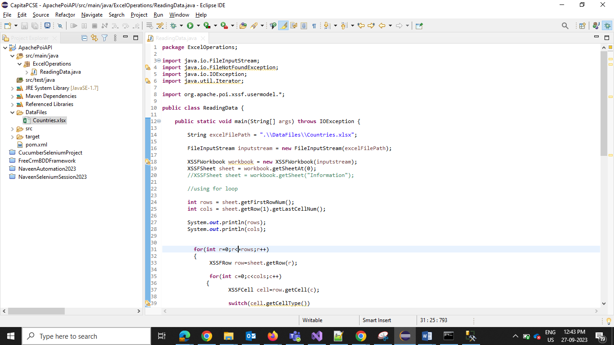

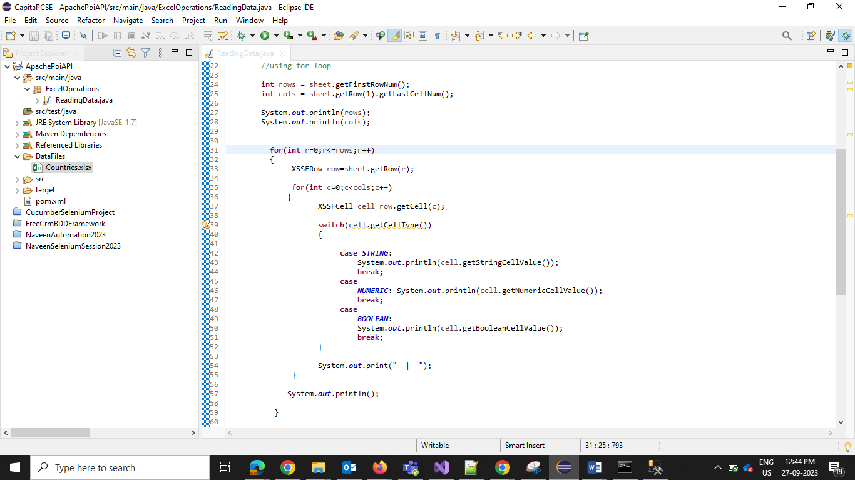

Using Iterator –

